TomorrowU Financial Literacy Video Game

Team Members: Christoper Stewart, Lesly Vega, Ashley Vega, Ethan Johnson, Brenden Swope and Colson Porterfield

CSCI-4326 – Senior Design – Spring 2026
Table of Contents
Contents
Product Definition 3
Project 3
Project URL 3
Team 3
Objectives 3
Audience 3
Motivation 3
Platform 3
Product Requirements 4
Project Architecture 10
Overall Architecture of the System 10
System Boundaries of the system 10
Context model for the system 11
Identifying 2 activities 12
Provide 2 use case diagrams with use case details 13
Sequence Diagrams 15
State Diagrams 17
Describe components in your system using class diagrams and their associations 18
Design and Implementation 19
Interface Specification for System Components 19
Objects along with attributes/methods and the Low-Level Design 19
Host Development Platform 20
Build Process Using the Configuration Management System 21
Target Execution System 21
Low Level Design: Day/Night Behavior Subsystem 22
Use of Open Source/Licensing Issues 23

Product Definition
Project TomorrowU Web demo and Expansion
Project URL https://github.com/EldredKirin/TomorrowUGameRepo
Team Christopher Stewart, Lesly Vega, Ashley Vega, Ethan Johnson, Brenden Swope, Colson Porterfield

Objectives
- Allow game TomorrowU to be played in browser.
- Refine/Expand playable content present in the game
Audience Teenagers and young adults.

Motivation TomorrowU’s purpose is to attract customers to the Legacy Institute for Financial Empowerment by offering an intellectually stimulating experience for Children of clients to enjoy.

Cybersecurity Aspect: TomorrowU does not have a Cybersecurity aspect, as no personal or account information is managed by the game, nor needed to play the game.

What system will you build: The base functionality of the game is present, so we are being tasked with making the game web based for higher availability, and after completing that, we will expand the game to increase enjoyability.

Member Roles Brenden Swope-Team Lead, Ethan Johnson-Developer, Chris Stewart-Developer, Colson Porterfield-Developer, Ashley Vega-Developer, Lesly Vega-Developer.
Because the Client wishes to prioritize porting to the web, needed roles for the expansion are unclear, and will likely change in the future.

Platform C Sharp using the Unity game engine.

Product Requirements
- Brenden
- The game should be run through the website that the client has running.
- The game must be ported into a version that is able to be run on the web.
- The game must either be rebuilt with the resources the developers have received from the client so that we can edit it or the developers can find a way to turn the game back into the base unity files to be able to edit it in the future.
- The game should include an edit that includes the bank sponsor into the game.
- The game should be improved as the developers see fit if there is enough time left.

- Chris and Lesly
  - Client - LIFE in Lufkin, TX. This is the organization that we are making the project for. They provided a general idea of how the game should function and what the game should be about.
  - End Users - Children of LIFE participants, these will be the primary users of the game. Our requirements and how the game will be is intended for them to play, such as difficulty of games for learning, engagement, simplicity, and accessibility.
  - Parents - We want the parents to see their child playing the game and see how it could benefit them and allow them to learn.
  - LIFE Website Administrators - Once we finish the game and manage to integrate it to their website, it will be up to them to maintain.
  - Development Team (us) - We are responsible for implementation and development of the game, then we will try to integrate the game into their website for it to be easily accessible by the users.
- Chris
  - Web-Deployment Compatibility - Unity allows projects to be exported as a WebGL build to ensure compatibility with modern web browsers.
  - Browser Performance - Since the game will run in a browser, we will minimize memory usage and asset sizes to allow for a minimal, smooth gameplay experience. Since it will be a 2D pixel art game, this should be fine.
  - No Database - The game will lose progress after the session terminates. Player progress will not be stored permanently because of the simplicity of the game.
  - 2D Game Architecture - We will utilize Unity’s 2D game engine in order to work on this project.
  - Mini-Game Structure - They will have classes such as math/science/shop, etc,. And they will be implemented as scenes in Unity.
  - Single-Player - Game will have no networking or multiplayer functionality.
  - Input - The game must support keyboard input for character movement and interaction, as well as mouse input for menu navigation and the mini-games.
  - Note: The game will be implemented using C# within the Unity game engine.

- Ashley - For this project, the two development methodologies considered are Agile and Scrum. From the set of possible requirements, we identified the minimal set of requirements necessary to deliver a shippable product. For Agile, the minimal set is discussed in the below table. This ensures the product is functional, accessible, and ready for delivery while avoiding nonessential features. For Scrum, the below table also discusses the user stories.

Agile | Scrum
The system should be developed using the Unity game engine. | Sprint 1 - As a player, I want to access the game through a website so that I can begin playing without installing software.
The system should be deployed as a WebGL application accessible through a web browser. | String 2 - As a player, I want to control the game using simple keyboard and mouse inputs so that the game is easy to play.
The system should load at least one playable game scene upon launch.
The system should allow users to interact with the game using keyboard and mouse input.

- Ashley - Requirements above are documented using structured language, tables, and Scrum user stories.
- Ashley - This is done with part 5 as well.

- Ethan - Based on the requirements listed above they can be broken up into sections like; setting up Unity and getting web configurations set up, taking the resources we were given from the client and rebuilding the project, port the game into a website, test / debug the ported web version, and deploy the game. To get Unity set up and configured it will take 1- 3 person days. Rebuilding the project will likely be most of the time and take anywhere from 21/40 person days. Debugging the ported version should only take 1-2 person days. Deploying the game should also only take 1-2 person days as well. This would give us a total of around 28 person days ideally which fits in our timeline, but also gives us 48 person days on the high side if we take extra time in development.

- Ethan - Since we are having to remake the game in order to port it to the web correctly our team has decided that it would take around 3 - 4 weeks to get it back to the current state that it is in right now. With that information we are planning on doing 2 week sprints,so that we can make sure we have enough time during that first week to figure out unity and get our plan in motion. Our velocity will be slow to start since we need to learn the environment, but once the team gains an understanding of how Unity works the velocity should increase steadily. Hopefully we can get a working product in around 2 sprints, but we might need 3 just based on how fast we pick up using Unity and how development goes.

- Ethan - Because we are doing Agile development, this section doesn't really apply to us.

- Lesly - Powerpoint / presentation will be similar to the word doc provided in order to be able to have everything organized and fully understandable.

Colson Porterfield — Risk and Mitigation
Risk Breakdown Structure
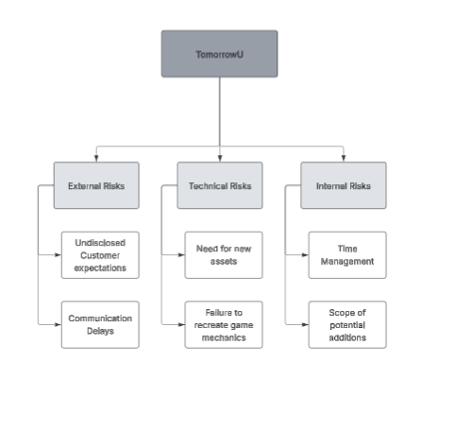
Risk Mitigation Plan - External Risks:
For external risks outside of our control, we will keep the customer updated with our progress to be as transparent as possible, and raise issues ASAP in order to allow for delays to occur without impact on development.

Technical Risks:
For technical risks, the need for new assets is not likely to arise, but would be critical, as there exists a potentially large time investment, so to mitigate that risk we will plan early what assets will be used where in order to properly account before a time crunch arises. A failure to recreate a game mechanic is similarly critical, but less likely to occur, and likely less time consuming to correct, but similar measures of early planning will be taken to avoid pitfalls.

Internal Risks:
Because of the unexpected development of work, less content will be possible to add because of the necessary redo of what exists currently of TomorrowU, and there is potential for a lack of time for the main development depending on program complexity and navigation of files our team is not entirely familiar with. This will be counteracted with cohesive planning that will show whether extra time or care is necessary for development.

Monitoring:
Most identified risks are not those which can be detected and corrected via observation, and if they arise they will have to be dealt with head-on by sinking more time into the project to course correct. The exception will be the Time Management of our team, which will be monitored through tasks being delegated and prioritized, with corrections to the assessment being made if the team is unable to meet original expectations

Project Architecture
Overall Architecture of the System (Brenden Swope)
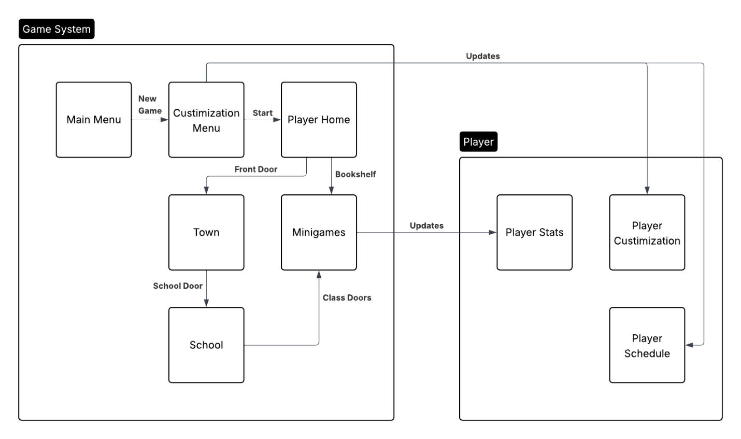

System Boundaries of the system (Ethan Johnson)
System Boundaries:
What’s inside the system:
User Interface:
- School and town map
- Simple displays for kids
- Phone to display player information
Lesson Engine:
- Logic that teaches basic math skills and basic personal finance principles
Reward system:
- Increase to your grades and character attributes when you complete a class or do a mini game in your room
Stat system:
- Phone to track class grades and attributes to your character

What’s outside the system:
The player:
- Primary user making the in-game decisions
Unity Engine:
- Handles the game rendering, audio, input, and makes sure the device being run on is compatible
The Device:
- The physical device running the game

What is out of the scope:
- Real banking account connection
- Multiplayer or shared progression to another game copy
- Content that is too advanced for a child such as complex math or complex finance topics

Context model for the system (Ethan Johnson)

Context model shows the system boundaries and how the system connects
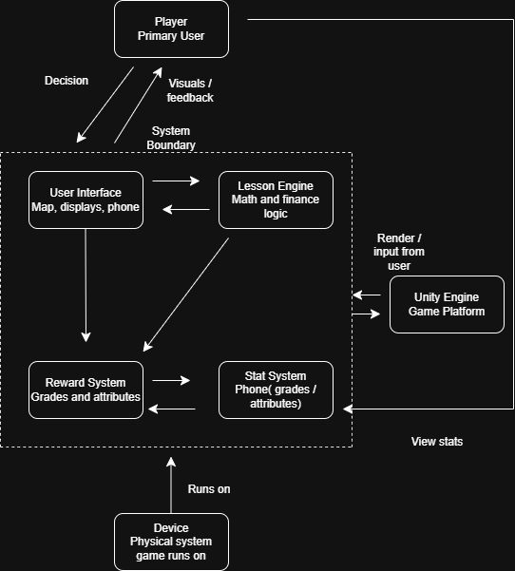

Identifying 2 activities (Lesly Vega)

Activity 1: Play a Mini-Game
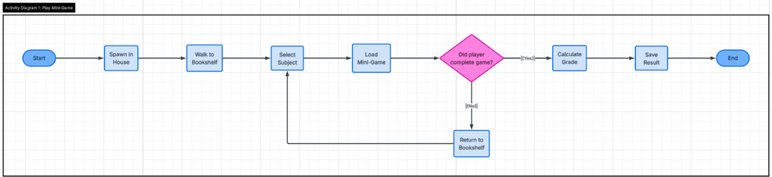
Activity 2: End of Semester - Update Stats based on Grades
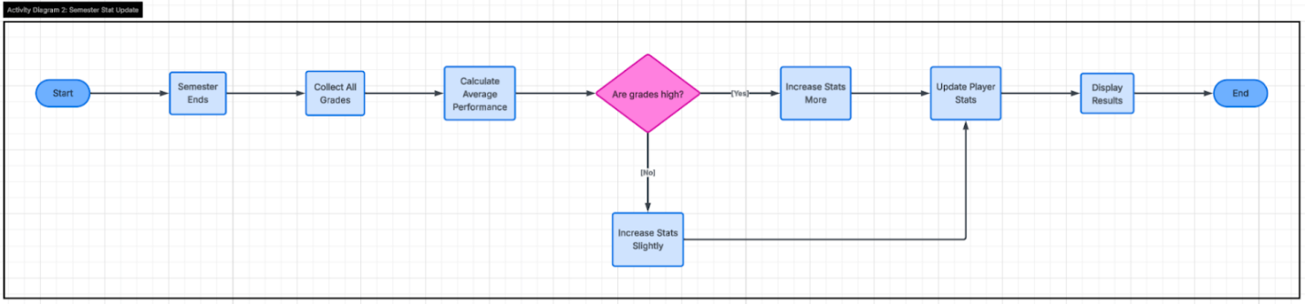

Provide 2 use case diagrams with use case details (Chris Stewart)

5.1) Minigames/Classes
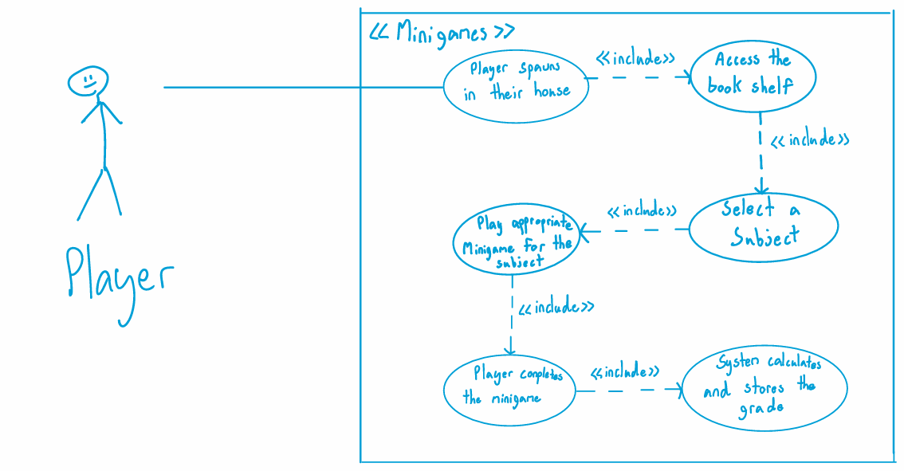
5.2) Semester & Progression
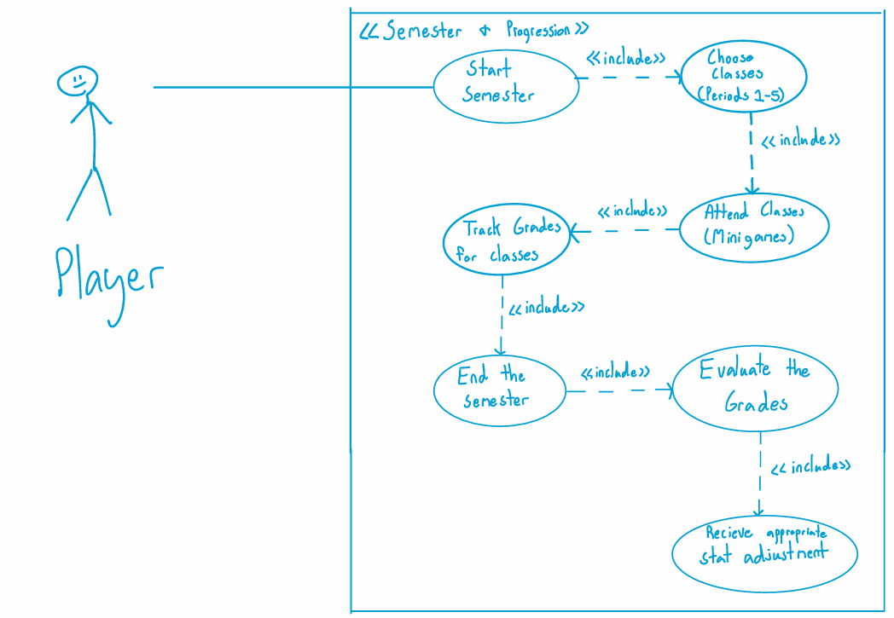

Sequence Diagrams (Colson Porterfield)

Sequence diagram depicts the events which occur when a player engages with a minigame.
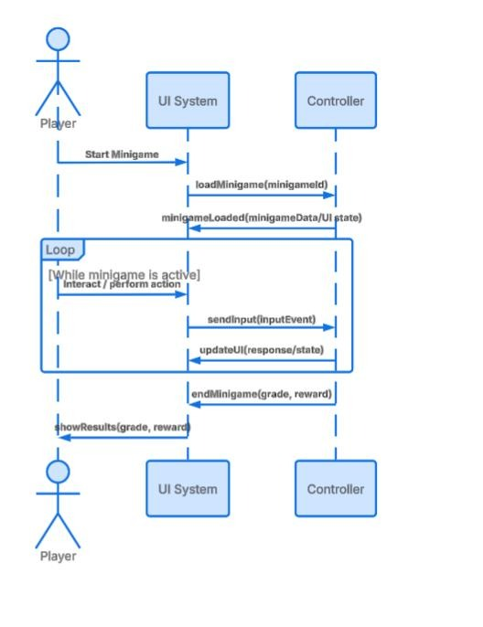
Sequence diagram depicting the events which occur when a player starts the game and creates their character.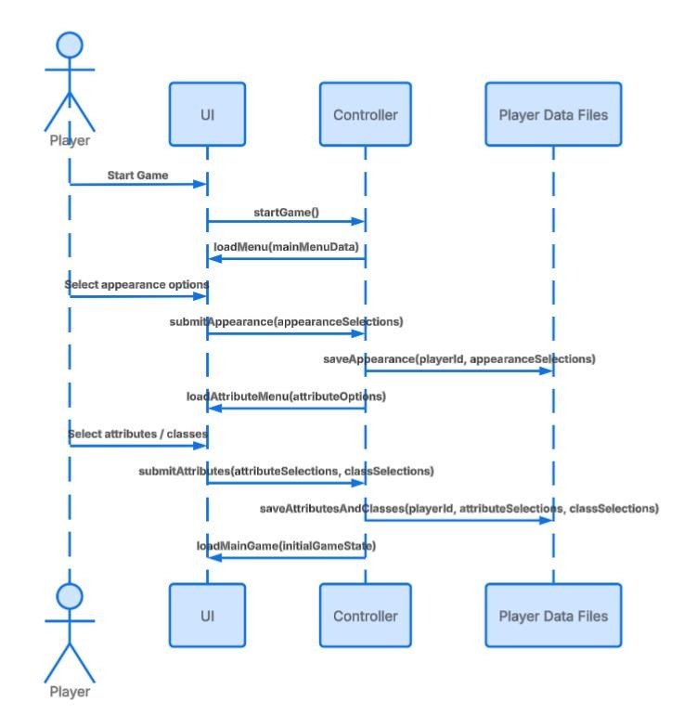

State Diagrams (Colson Porterfield)

State Diagram for the flow of actions during a minigame.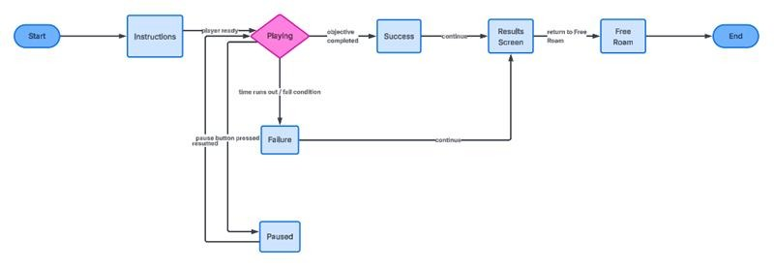

State Diagram for the flow of actions taken by a player in an in-game day cycle.
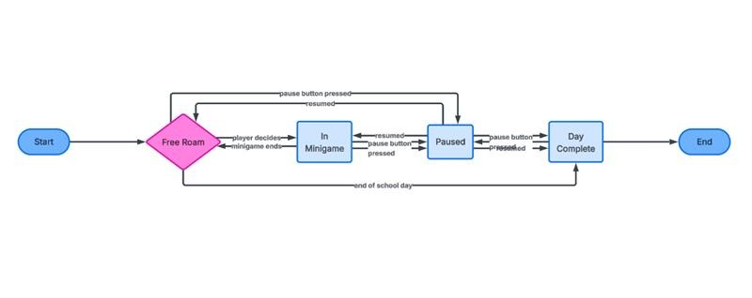

Describe components in your system using class diagrams and their associations (Ashley Vega)
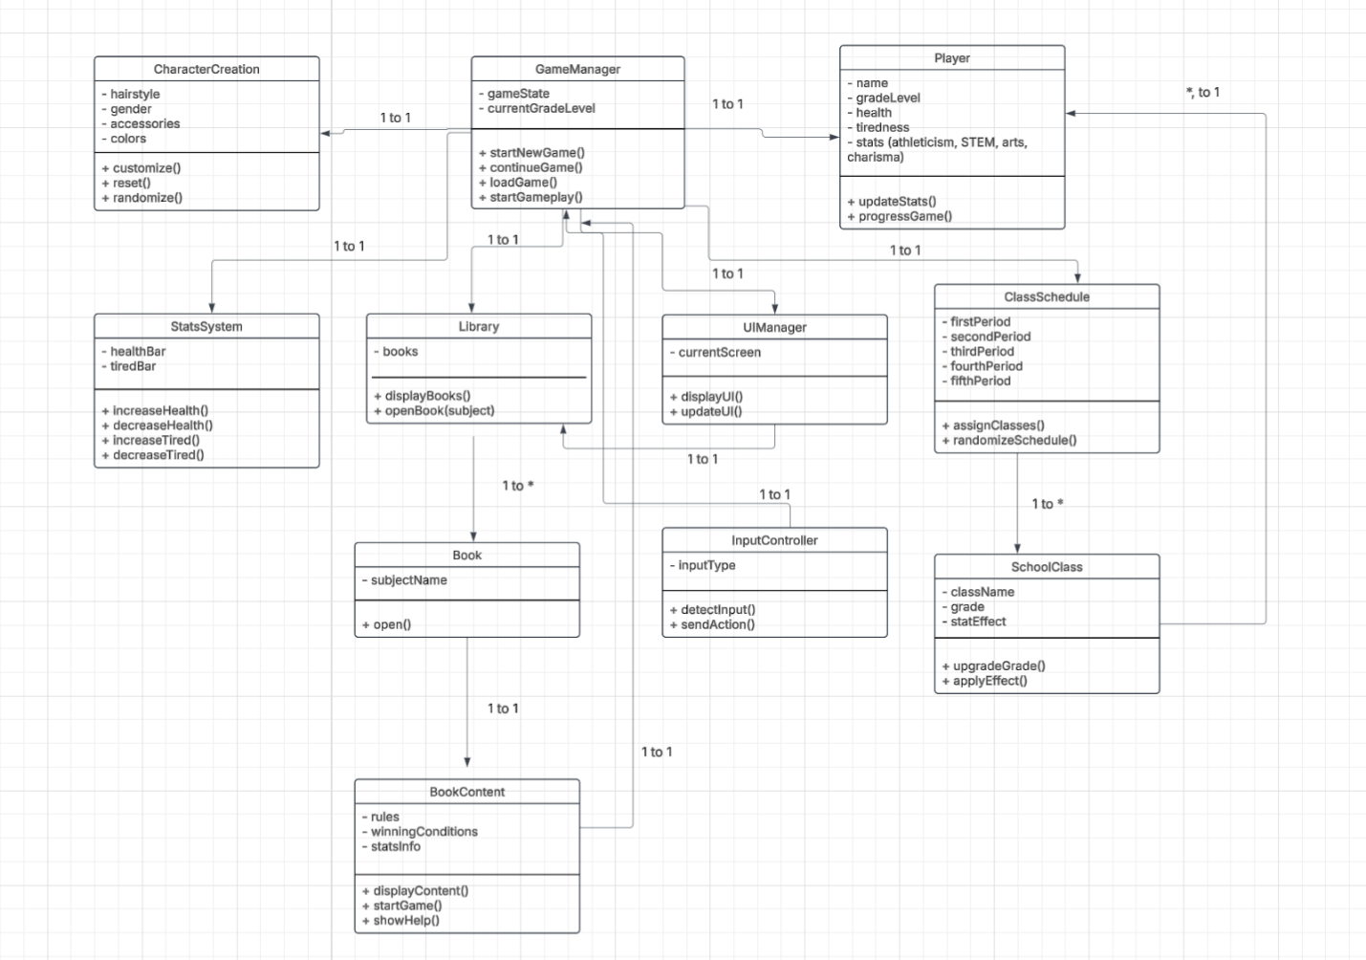

Design and Implementation

Interface Specification for System Components
The TomorrowU game is made up of several main components such as user interface, lesson engine, reward system, and stat system. The first component, the user interface, is the main component with it being the school/town map, and the main thing that the user interacts with as they play the game. This component takes in keyboard events for movement, mouse events, and renders scenes as the player navigates the game. The next component is the lesson engine, and this holds most of the logic for the mini game function in the game which helps teach the user about financial literacy. The main input is through the keyboard or mouse and will base questions on the answers that the user gives. This component also evaluates the score of the user in the mini game and will send it to the next components, the reward system, and the stat component. The reward system is connected and dependent on the lesson engine and how well the user does on a mini game as that will determine how much they have to add to their characters attributes. This system is also connected to the classes and will determine the grades they have in a class within the game. That leads to the last component of the game, the stat system. The stat system is a way for the user to be able to see the progress they have made in the session and also connects to the reward system as it will help display the information for class grades and also character attributes. The stats will reset with a new game and same for all the other components of this game as there is no local save functionality. All the components in the game connect to each other in some manner and are dependent on each other as well.

Objects along with attributes/methods and the Low-Level Design
The TomorrowU system is made up of several main objects that define how the game works using object-oriented design. The GameManager acts as the main controller and is responsible for handling the overall flow of the game. It uses attributes like gameState and currentGrade, and includes methods such as startNewGame(), continueGame(), loadGame(), and startGameplay() to move between different parts of the game. The Player object stores all information about the user, including name, gradeLevel, health, tiredness, and stats like athleticism, STEM, arts, and charisma, and uses methods like updateStats() and progressGrade() to track progress. The CharacterCreation object allows the player to customize their character using attributes like hairstyle, gender, accessories, and colors, with methods to customize, reset, or randomize the character. The ClassSchedule object manages the player’s selected classes for each period and works with the SchoolClass object, which represents individual subjects like Math, Science, or Gym. Each SchoolClass has attributes such as className, grade, and statEffect, and methods to update grades and apply stat changes to the Player. The StatsSystem handles the player’s healthBar and tiredBar, with methods to increase or decrease these values based on gameplay. The Library object contains multiple Book objects, each representing a subject, and each Book includes a BookContent object that displays rules, winning conditions, and stat information, along with methods to display content, start the game, and provide help. The UIManager is responsible for displaying screens and updating the interface, while the InputController handles player actions such as button clicks and sends those actions to the correct part of the system. These objects represent the major components of the system. Supporting and helper classes used for implementation details are not included for brevity.
For the low-level design, the GameManager controls how the game transitions between states by following specific steps in its methods. The startNewGame() method sets the gameState to CharacterCreation, resets or creates a new Player object, and tells the UIManager to display the character creation screen. The continueGame() method loads saved player data, restores stats and grade level, updates the gameState, and updates the UI to match the current progress. The loadGame() method retrieves stored data and applies it to the Player and other system components. The startGameplay() method sets the gameState to Playing, loads the selected classes from the ClassSchedule, initializes the StatsSystem, and updates the UI so the player can begin gameplay. Overall, each object has a clear responsibility, which keeps the system organized and makes it easier to maintain and expand.

Host Development Platform
The host development platform consists of the tools and environment used by the development team to build, edit, and manage the project.
IDE: The primary IDE used for scripting and code editing is Visual Studio Code (VS Code). Unity Editor 2020.3.5f1 serves as the game engine and project editor, providing the scene editor, asset pipeline, and integrated build tools.
Compiler: Unity 2020.3.5f1 uses the Mono compiler with .NET Standard 2.0 scripting backend for WebGL builds. C# is the scripting language used throughout the project.
Configuration Management System: Github was used as the primary method for version control and progress syncing. The repository is primarily maintained on the main branch, reflecting the team’s workflow given the constraints encountered during development.
Test Tools: Testing was conducted using Unity’s built-in Play Mode, which allows developers to run and interact with the game directly within the Unity Editor without a separate build step. No additional automated testing frameworks were integrated.

Build Process Using the Configuration Management System
The build process covers the steps required to go from the version-controlled source to a deployable product.

- The project repository is hosted on GitHub. Developers clone the repository and open it in Unity Editor 2020.3.5f1 to begin work.

- Changes are committed and pushed directly to the main branch. Due to the project timeline and recovery constraints, a formal branching strategy was not implemented.

- To build the project, the developer navigates to File > Build Settings in Unity Editor, selects WebGL as the target platform, and initiates the build. Unity’s asset pipeline compiles all scripts and assets into a deployable WebGL output.

- The resulting WebGL build files are then uploaded to GitHub for browser-based deployment. No automated CI/CD pipeline or build scripts were used; the process is performed manually within Unity.

Target Execution System
The target execution system describes the environment in which the final product is expected to run.
Platform: The game is intended to run in a web browser via a WebGL build. Users access the application through a hosted URL, requiring no local installation.
Minimum System Requirements: As a browser-based WebGL application, the minimum requirements are largely dictated by browser and hardware for WebGL support. A modern browser (such as Chrome, Firefox, or Edge) with WebGL 2.0 support is required. A mid-range GPU with WebGL capability, at least 4 GB of RAM, and a stable internet connection for initial load are recommended.
Libraries and Support Software: The application relies solely on the Unity WebGL runtime, which is bundled into the build output and loaded by the browser. No external libraries, plugins, or third-party packages are required on the client side.
Databases: The project does not use a database. A local save system was present during development targeting standalone builds; however, this functionality is not supported in the WebGL deployment environment due to browser sandboxing restrictions. As a result, no persistent data storage is present in the browser-hosted version.
Hosting: The build files are hosted via GitHub, making the execution environment fully browser-based with no dedicated server or cloud infrastructure required.

Low Level Design: Day/Night Behavior Subsystem
The Day/Night Behavior subsytem controls the lighting changes in the game based on the player’s current time of day. This component is implemented through the DayNightBehavior C# script in Unity. The script is attached to a game object that contains a Light2D component, which allows the scene lighting color to change during gameplay. The script uses a PlayerStats object to get the current in-game time through getTimeOfDay() method. One the time is received, the script checks whether the player is inside or outside the isInterior boolean. If the player is not inside, the script changes the Light2D color depending on the time of day. For example, if the time is between 7 and 8, the light changes to a warm morning color. If the time is between 9 and 15, the light becomes a normal white daytime color. If the time is between 16 and 17, the light changes to an evening color. Once the time reaches 18 or later, the light changes to a darker blue night color. This helps the environment feel more realistic and shows the player that time is passing in the game. Overall, this subsystem is important because it improves the visual experience of the game and connects the lighting system to the player’s in-game time. It also helps them realize that maybe they should ‘sleep’ which ends the day/semester. It is a small but useful part of the system because it automatically updates the atmosphere without the player needing to do anything.

Use of Open Source/Licensing Issues
We didn’t use any open-source software in this project since everything was done using Unity. Because of that, we didn’t run into any issues with open-source licenses or needed to give credit to outside libraries. We just followed the normal terms that come with Unity, which is owned by Unity Technologies. Overall, there weren’t any problems related to licensing.

